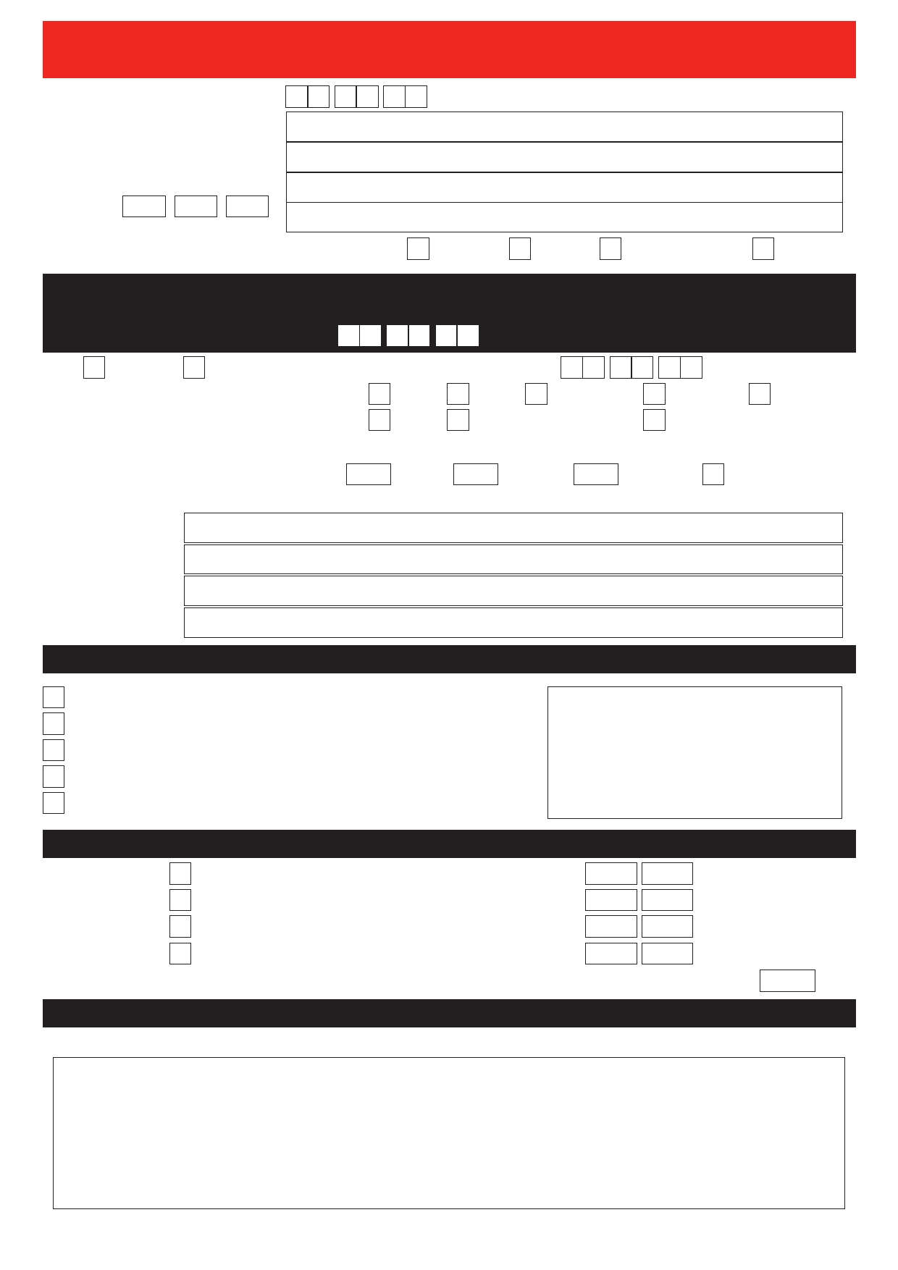

Today's date
International study of stroke prevention procedures
(Annual questionnaire; please complete BOTH pages)

Patient name (please PRINT)
Address (please PRINT), if
different from that on the letter
Patient ID - - (incl. tel & email, if known)
(from letter, to avoid mix-ups)
Please tick a box to say who filled out this form Patient Carer Friend/relative Other

We hope you have been well since leaving hospital after the neck artery procedure
(CEA/CAS) you had when you first joined the study, but if not then please tell us.

1. Since you were last contacted have you had a stroke?
Tick Yes, or No. If YES, what was the approximate date? d d m m y y
Which side of your body was affected? Left Right Neither side Both sides Don't know
Where were you treated? (can tick more than 1) Home Hospital/Clinic Other (eg, nursing home)
In total, how long were you in a hospital, clinic or nursing home because of it?
days, or weeks, or months, or tick if still there
Do you know the name and address of a doctor who saw you (or of the hospital you went to)?

Name (PRINT):
Address (PRINT):

2. If you have had a stroke, how are you now? (Tick ONE box)

No symptoms from the stroke
Minor problems, but I can carry out everything I usually do
A few problems from the stroke, but I can manage without help
Problems from the stroke, I now need help with things Because of the stroke I now need help with most things

Anything else you'd like to tell us?

3. Since your first CEA/CAS, have you had any further neck artery procedures?
Tick box if YES: | Operation (CEA) on my LEFT neck artery | Date | / | (month/year, approx)
 | Stent (CAS) in my LEFT neck artery | Date | / | (month/year, approx)
 | Operation (CEA) on my RIGHT neck artery | Date | / | (month/year, approx)
 | Stent (CAS) in my RIGHT neck artery | Date | / | (month/year, approx)
If any answer is YES, did you have a stroke within the first month after the procedure? Yes or No
4. Which medications do you take regularly?

Please PRINT the names of all prescription medicines you take regularly (ie, on most days), or state NOT KNOWN

continued over the page…

ACST/FU2/1/1207

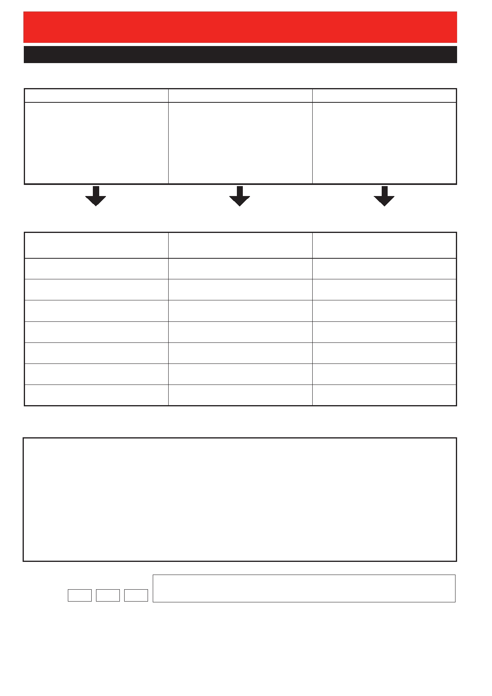
International study of stroke prevention procedures
(Annual questionnaire; please complete BOTH pages)

5. Contact details
You gave us this information when you joined this study. We may need to contact one of these people if
we cannot contact you when we write to you again next year.
Your family doctor Your first friend or relative (1) Your second friend or relative (2)

Please give new contact details, if they differ from those above
(thereby renewing your permission for us to contact them if necessary)
New name or contact details* for N e w n a m e o r c o n t a c t d e t a i l s* f o r N e w n a m e o r c o n t a c t d e t a i l s* f o r
my family doctor (PRINT) my first friend or relative (PRINT) my second friend or relative (PRINT)

* (including tel. & email, if known)
Thank you very much. Do you have any comments, further information or questions?

Name of person completing this form, signature and date

Patient ID- -

Please put this form in the prepaid envelope provided (no stamp is needed),

OR post it in another envelope (with a stamp) to ACST-2 Richard Doll Building, University of Oxford, Old Road, Headington, Oxford, UK OX3 7ZF (March 2020)

ACST-2 Richard Doll Building,
University of Oxford,
Old Road,
Headington,
Oxford, UK
OX3 7ZF

Tel: +44 (0)1865 221345
Email: acst@nds.ox.ac.uk
Website: acst.org.uk
NIHR HTA/BUPA Foundation/University of Oxford
Asymptomatic Carotid Surgery Trial – 2
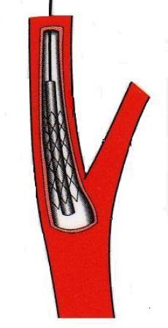

Study ID number: <<id number>>

Dear Patient
On <<randomization date>> you agreed to take part in an international study comparing two different procedures, CEA or CAS, to treat a narrowed artery in your neck in the hope of preventing stroke. I am now writing to find out how you have been since leaving hospital after having that procedure (CEA or CAS).
I need to know if you have had any kind of stroke since then and, if so, whether it still affects you. I hope that you will continue to be part of this study, and I would like to write to you again one year from now.
Please complete the short form and send it back in the envelope. If you cannot complete this form yourself, perhaps a friend, relative, carer or doctor can help. Thank you.


Dr. Alison Halliday, study director
Information you had before you joined the study (and, on the next sheet, a copy of your previous agreement to join it)
Before you joined this study, your doctor had told you that you had a narrowing in one of the arteries in your neck that supplies blood to the brain, and that this narrowing could cause a stroke. Your doctor felt that it was time to deal with this narrowing. This study compares removing the narrowing by an operation (called carotid endarterectomy, CEA) or by keeping the inside of the artery open with a wire mesh tube (a procedure called carotid artery stenting, CAS), to see which is better. The findings of this study will help people like you in the future who have a narrowing in their carotid arteries.
You were told that we would want to write to you once a year for at least 5 years to ask you how you are. If we cannot contact you, we would like to ask your family doctor (or any friends or relatives you named) how you have been.
(March 2020)


By placing a tick in one box in each group below, please indicate which statements best describe your own health state today.

Mobility
I have no problems in walking about 
I have some problems in walking about 
I am confined to bed 

Self-Care
I have no problems with self-care 
I have some problems washing or dressing myself 
I am unable to wash or dress myself 

Usual Activities (e.g. work, study, housework, family or
leisure activities)
I have no problems with performing my usual activities 
I have some problems with performing my usual activities 
I am unable to perform my usual activities 

Pain/Discomfort
I have no pain or discomfort 
I have moderate pain or discomfort 
I have extreme pain or discomfort 

Anxiety/Depression
I am not anxious or depressed 
I am moderately anxious or depressed 
I am extremely anxious or depressed 

Patient ID:

Signed: _____________________________ Date: _________________
(March 2020)

