ACST-2 TRACK RECORD FORM

Which procedure(s) do you carry out YOURSELF? | CEA |  | CAS |  | Both

 | CEA  You must have done a minimum of 25 procedures (ideally in the last 2 years) |  |  |  | CAS  You must have done a minimum of 25 procedures (ideally in the last 2 years)
Total number of procedures
Between (mm/yyyy): |  | and |  |  |  | and
Proctored Procedures | N/A
Number of Symptomatic patients

Results within 30 days AFTER procedure:
How many suffered stroke?

Number of fatal strokes?

Number of procedure related deaths (non-stroke)

Number of Asymptomatic patients

Results within 30 days AFTER procedure:
How many suffered stroke?

Number of fatal strokes?

Number of procedure related deaths (non-stroke)

Number of procedures in the last two years

Please provide any additional information which you consider relevant

Name of Centre:
This track record is for NAME: |  |  |  |  | Specialty:

VERIFICATION STATEMENT: I CONFIRM THE OUTCOME OF THESE PROCEDURES AS STATED ABOVE:-
(to be signed by a Consultant Neurologist or Stroke Physician)
Neurologists / Stroke Physician (Print Name): |  |  |  | Speciality:
Signature: |  | Date: |  | (dd/mm/yyyy)
Once completed, please send back to Luisa Teixeira either by fax to +44 (0)1865 221 027
or e-mail: luisa.teixeira@nds.ox.ac.uk
Thank you!

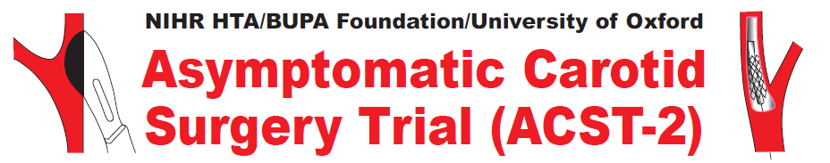
Title
Given name
Family name
Position/Job
Department
Hospital
Address 1
Address 2
Address 3
City
Country
Email address
Telephone number
Fax number
Contact Details

Please take a moment to fill out the below form, so we can update
our records accordingly.

Many thanks.

Thank you for taking the time to complete this.

Contact Us:
Tel: +44 (0)1865 221 345, Fax: +44 (0) 1865 221 027
Or by post to: ACST-2 Trials Office, Nuffield Department of Surgical Sciences, Level 6,
John Radcliffe Hospital, Headington, Oxford, OX3 9DU, UK.
e-mail:acst@nds.ox.ac.uk

